**Exercise 4: Creating and Configuring a Maven Project**

**This exercise can be completed by following 3 major steps:-**

**Step 1.** Create a New Maven Project->  
 If you're using **IDEA (IntelliJ)** or **Eclipse**, you can create the project using the UI. Alternatively, you can use the **command line**:

mvn archetype:generate -DgroupId=com.library -DartifactId=LibraryManagement -DarchetypeArtifactId=maven-archetype-quickstart -DinteractiveMode=false

This creates a basic Maven project structure.

### Step 2. Add Spring Dependencies in pom.xml

Edit the pom.xml file inside the LibraryManagement directory and add the following Spring dependencies:

You can Download these dependencies from MVN central repository  
just search and copy it into the pom.xml files dependencies tag.

You can download it from here :- [**https://mvnrepository.com**](https://mvnrepository.com)

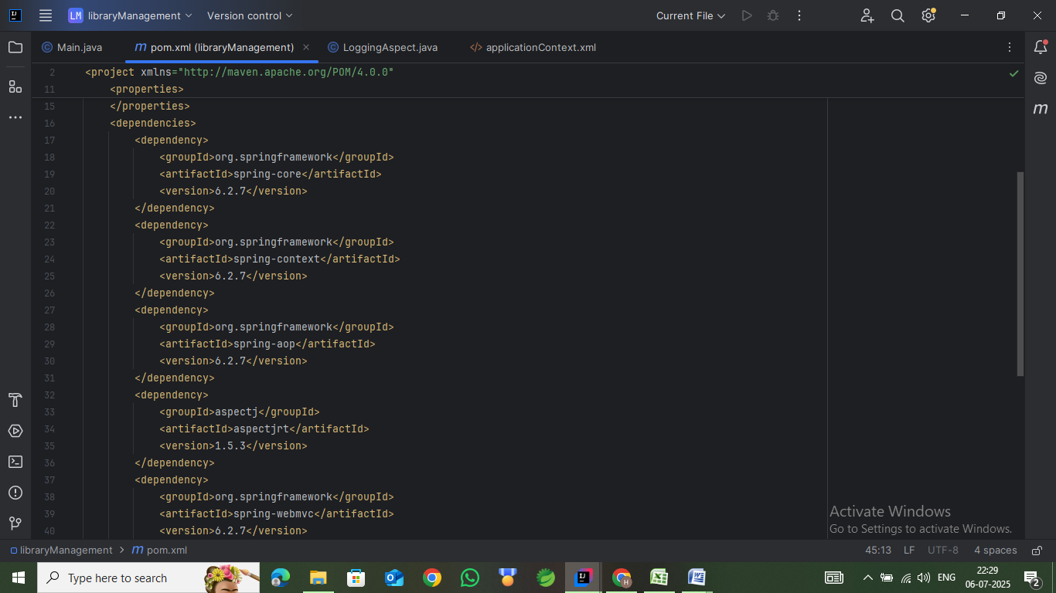

**Step 3 :- Enter the plugin into into plug tag and Build the project**

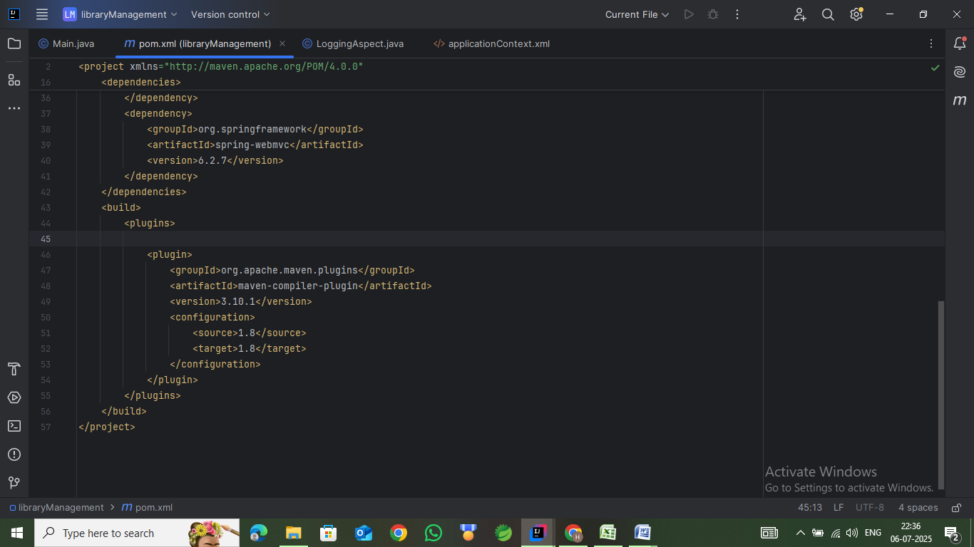

Then run the following command **mvn** **clean install**You will have you project configured and running.

It will show something like this,  
